# Exercises: Streams, Files and Directories

This document defines the exercises for ["Java Advanced" course @ Software University](https://softuni.bg/modules/59/java-advanced). Please submit your solutions (source code) of all below described problems in [Judge](https://judge.softuni.bg/Contests/1506/Streams-Files-And-Directories-Exercises).

**For these exercises, you are given a zipped folder with resources that you will need to use. For each exercise submit the output of the program, not the code.**

## Sum Lines

Write a program that reads a text file ("**input.txt**" from the Resources - Exercises) and prints on the console the **sum** of the ASCII symbols of each of its lines. Use BufferedReader in combination with FileReader.

### Examples

|  |  |
| --- | --- |
| **Input** | **Output** |
| On January 1 , 1533 ,  Michael Angelo,  then fifty-seven years old,  writes  from Florence to  Tommaso de' Cavalieri,  a youth of noble Roman family, | 1452  1397  2606  670  1573  2028  2762 |

### Hints

* Use try-with-resources to handle the file.

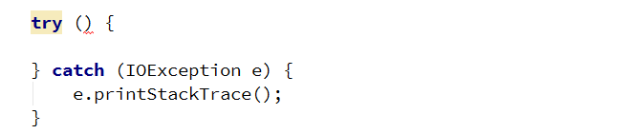

* Create a BufferedReader to read each line of the file.

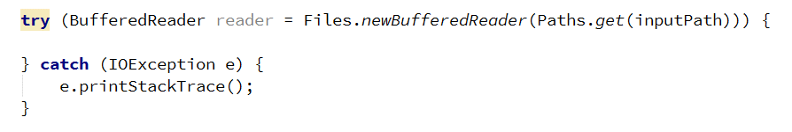

* Get the ASCII code of each character in the line and **add** it to the **sum** for the current line and print the sum on the console.

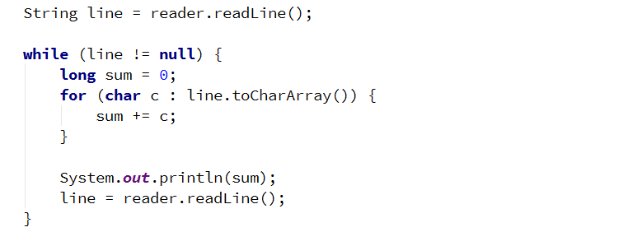

## Sum Bytes

Write a program that reads a text file ("**input.txt**" from the Resources - Exercises) and prints on the console the **sum** of the ASCII symbols of all characters inside of the file. Use BufferedReader in combination with FileReader.

|  |  |
| --- | --- |
| **Input** | **Output** |
| On January 1 , 1533 ,  Michael Angelo,  then fifty-seven years old,  writes  from Florence to  Tommaso de' Cavalieri,  a youth of noble Roman family, | 12488 |

### Hints

* You can modify your solution to the previous problem.
* Use a type that will not overflow like long or BigInteger.

## ALL CAPITALS!

Write a program that reads a text file ("**input.txt**" from the Resources - Exercises) and changes the casing of **all** letters to the **upper**. Write the output to another file ("**output.txt**").

### Examples

|  |  |
| --- | --- |
| **Input** | **Output** |
| On January 1 , 1533 ,  Michael Angelo,  then fifty-seven years old,  writes  from Florence to  Tommaso de' Cavalieri,  a youth of noble Roman family, | ON JANUARY 1 , 1533 ,  MICHAEL ANGELO,  THEN FIFTY-SEVEN YEARS OLD,  WRITES  FROM FLORENCE TO  TOMMASO DE' CAVALIERI,  A YOUTH OF NOBLE ROMAN FAMILY, |

### Hints

* Use BufferedReader andPrintWriter.

## Count Character Types

Write a program that reads a list of words from the file ("**input.txt**" from the Resources - Exercises) and finds the count of **vowels**, **consonants,** and **punctuation** marks. Assume that:

* **a, e, i, o, u** are vowels, only lower case.
* **All** **others** are consonants.
* Punctuation marks are **(! , . ?).**
* **Do** **not** count whitespace.

Write the results to another file – "**output.txt**".

### Examples

|  |  |
| --- | --- |
| **Input** | **Output** |
| On January 1 , 1533 , Michael Angelo, then fifty-seven years old, writes  from Florence to Tommaso de' Cavalieri, a youth of noble Roman family, | Vowels: 41  Consonants: 72  Punctuation: 6 |

### Hints

* Use BufferedReader andPrintWriter.

## Line Numbers

Write a program that reads a text file ("**inputLineNumbers.txt**" from the Resources - Exercises) and **inserts** line numbers in front of each of its lines. The result should be written to **another** text file – "**output.txt**".

### Examples

|  |  |
| --- | --- |
| **Input** | **Output** |
| Two households, both alike in dignity,  In fair Verona, where we lay our scene,  From ancient grudge break to new,  Where civil blood makes civil hands.  From forth the fatal loins of these two  A pair of star-cross'd lovers take their life;  Whose misadventured piteous overthrows  Do with their death bury their parents' strife. | 1. Two households, both alike in dignity,  2. In fair Verona, where we lay our scene,  3. From ancient grudge break to new,  4. Where civil blood makes civil hands.  5. From forth the fatal loins of these two  6. A pair of star-cross'd lovers take their life;  7. Whose misadventured piteous overthrows  8. Do with their death bury their parents' strife. |

## Word Count

Write a program that reads a list of words from the file "**words.txt**"(from the Resources - Exercises) and finds how many times each of the words is **contained** in another file "**text.txt**"(from the Resources - Exercises). Matching should be **case-insensitive**.

Write the results in file "**results.txt**". Sort the words by frequency in **descending** **order**.

### Examples

|  |  |
| --- | --- |
| **Input** | **Output** |
| of which The | of - 6  which - 2  The - 1 |

## Merge Two Files

Write a program that reads the contents of **two** text files ("**inputOne.txt**", "**inputTwo.txt**" from Resources - Exercises) and **merges** them into a third one.

### Examples

|  |  |  |
| --- | --- | --- |
| **File 1** | **File 2** | **Output** |
| 1  2  3 | 4  5  6 | 1  2  3  4  5  6 |

## Get Folder Size

Write a program that **traverses** a folder and **calculates** its size in bytes. Use Folder **Exercises** **Resources** in Resources.

### Examples

|  |  |
| --- | --- |
| **Input** | **Output** |
|  | Folder size: 2878 |

## Copy a Picture

Write a program that makes a copy of a **.jpg** file using FileInputStream, FileOutputStream, and byte[] buffer. Set the name of the new file as "**picture-copy.jpg**".

## Serialize Array List

Write a program that saves and loads an ArrayList of doubles to a file using **ObjectInputStream** and **ObjectOutputStream**. Set the name of the file as "list.ser"**.**

## *Serialize Custom Object

Write a program that saves and loads the information about a custom object using **ObjectInputStream** and **ObjectOutputStream**.

Create a **simple** **class** called "**Course**" that has a **String field** containing its **name** and an **integer field** containing the **number of students** attending the course. Set the name of the save file as "course.ser"**.**

## *Create Zip Archive

Write a program that reads three **.txt** files and creates a zip archive named "**files.zip**"**.** Use FileOutputStream, ZipOutputStream, and FileInputStream**.**